**Personal Portfolio**

*Front End Development Project*

What is a personal portfolio?

Portfolios provide you with a personal record of your success or improvement in a range of areas. They are essential and relevant to your own career development.

So, I decided to make a site which shows a true reflection of myself in both academic and non-academic environments. It includes my overall work and achievements in the field of academics. Also, it includes my other adventures apart from the achievements. If a recruiter asks: who is Pulkit? I’ll just share the link of the portfolio and he will get to know everything about me that he needs to know.

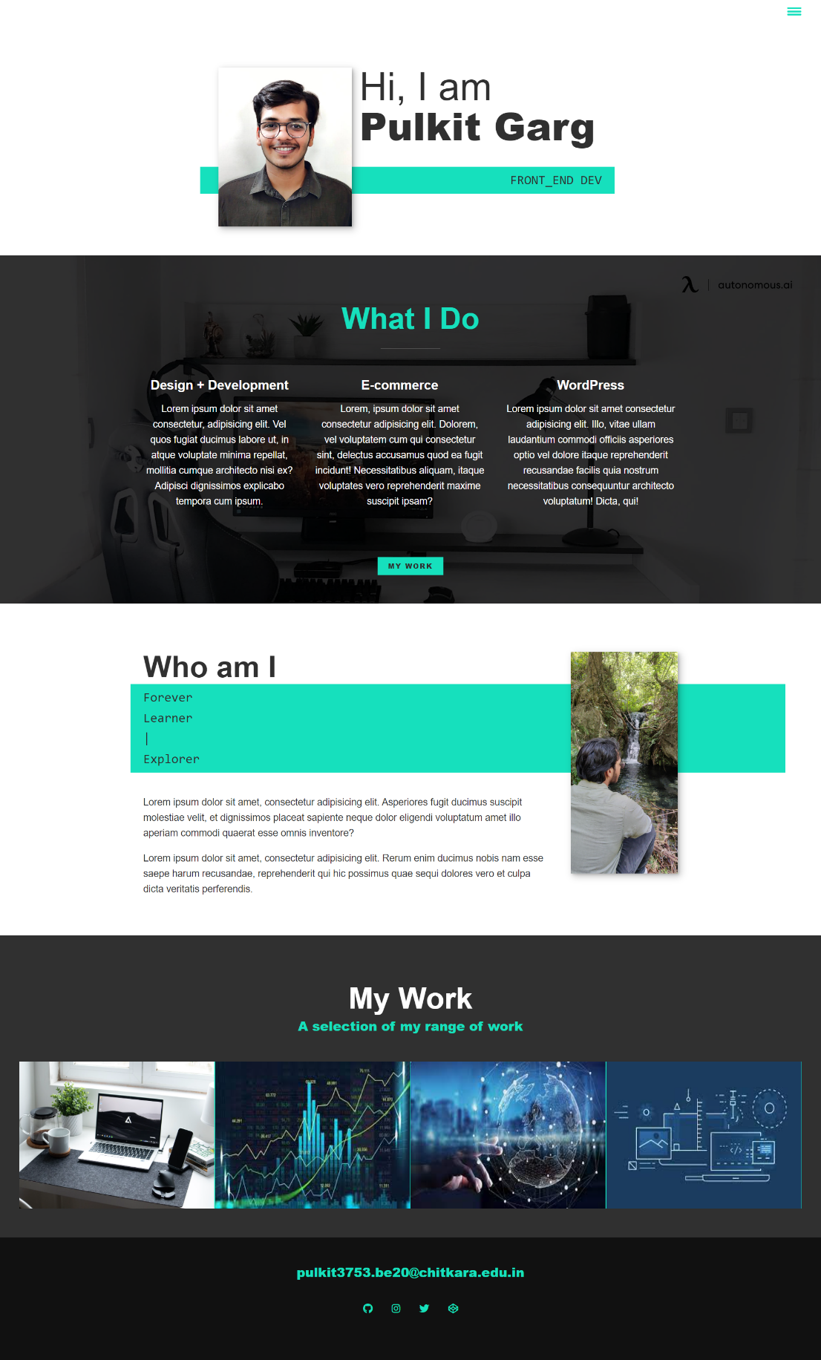

***Components***

* As we open up the site, the first thing that prompts up is a text saying *“Hi, I am Pulkit Garg”* along with a portrait of myself. Below that we can see that there is a job-tile which gives you a brief idea about what is my field of work.
* On the top right corner, you can see a hamburger symbol. This represents a nav-bar as you will click on this button a menu will prompt on your screen. You can select the section you want to go to form the menu. As you will hover over the section names you will observe a change in colour showing which section you are referring to.

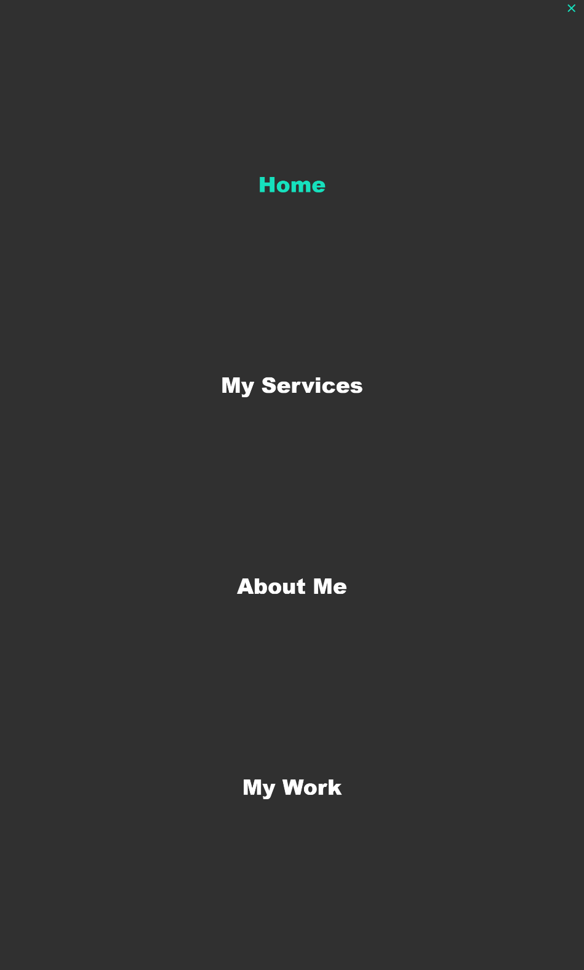

* The whole website is divided into multiple sections:
* ***What I do***: This section tells about all the different fields I am familiar with or have worked in them. It just gives a gist of what I have already done. Below you will be able to observe a button labelled as *“MY WORK”* which on clicking will redirect the user the ***My Work*** section.
* ***Who am I***: This section is more about myself apart form the academics and professionalism, what do I do in my free time, what all hobbies do I have, what all things are in my to-do list. Alongside you can also see a portrait of me sitting along a riverside trying to look aesthetic.
* ***My Work***: This section focuses on all the projects I have completed till now. You will be able to see multiple tiles. When you hover over the tile you will be able to observe that the image inside in zooms a bit and you’ll be able to see a transparency in the image. On clicking any image it will redirect the user to the page explaining the project.
* ***Contact***: The last but certainly not the least is the contact section where you will be able to see my email-id. When you hover over it you will observe that it will get underlined and on clicking it will open your mailbox in order to send a mail to me. Below them you will eb able to see the icons multiple social handles. On clicking them they will redirect the user to my social handle account.